Research on Challenges Employees in Dubai Islamic bank
Name
Institution
Date

Contents
ABSTRACT 4
CHAPTER 1 5
INTRODUCTION 5
1.0 Introduction 5
1.1 Background 5
1.2 Problems statement 6
1.3 Objectives 6
1.4The Importance of Research 6
1.5 Methodology 6
1.6Definitions 6
1.7 Sources 7
CHAPTER TWO 7
LITERATURE REVIEW 7
2.0 Introduction 7
2.1 Staff with required skills 8
2.2 Sales Management 8
2.3 Attracting Customers 8
2.4 General Observations about the literature review 9
2.5 Benefits of literature review 9
CHAPTER THREE 9
METHODOLOGY 9
3.0 Introduction 9
3.1 Research Methodology 10
3.2 Research Approach 10
3.3 Design 10
3.4 Data 10
3.5 Constraints 10
CHAPTER FOUR 11
ANALYSIS OF DATA 11
4.0 Introduction 11
4.1 skills of employees are essential in developing the institution 12
4.2 Bank interest in bringing customers 13
4.3 bank interest in developing the skills of employees 13
4.4 Customer service benefits to the bank 14
4.5suggestions for an increase in sales 15
CHAPTER FIVE 15
Discussion 15
5.1 Importance of developing skills 15
5.2. Interest in bringing in customers 16
5.3. Banks interest in improving the employees skills 16
5.4 The benefits of customer service for the bank 16
5.5 Suggestion for sales increase 16
CHAPTER SIX 17
RECOMMENDATIONS AND CONCLUSIONS 17
6.0 Introduction 17
6.1 Important Issues 17
6.2 Challenges and Recommendations 17
6.3 Future Research 18
6.4 Conclusion 18

ABSTRACT
The research is mainly concerned about the challenging faced by the employees working in the United Arabs Emirates banking industry, specifically in Dubai Islamic bank (DBI). A research was conducted on DBI identify the challenges faced by the employees between 5th and 22nd of March, 2020. The results obtained aided in ascertaining the correlation between the employee challenges and the deteriorating performance of DIB. The objectives of the research include generating results that will assist in developing employee skills. Also, investigating the nature and increase of the sales and bring out ways of attracting customers to the banks are the last objectives of the study. The literature review confirmed that DIB has been struggling with the above-named aspect, and it is proven in the methodology part with the aid of descriptive statistics and observation. The sample used was composed of 200 participants, and recommendations are provided to address the challenges faced by the DIB bank.

CHAPTER 1

INTRODUCTION

1.0 Introduction
There are various strategies applied in Islamic banks, and they have been a significant threat to economic development since their interception. Abdul-Majid, Saal & Battisti, (2010) opine that a considerable number of Islamic banks, including Dubai Islamic Bank, have been battling with the transitioning from the theoretical framework to the practical aspect of the operation. Based on scientific practice, the establishment of banks and economic institutions that are concerned about riba face new challenges consistently, thereby becoming a significant obstacle to those who are trying to reconstruct and revive the banking systems (Hassan & Aliyu, 2018). It is, however, worth noting that the banking system functions concerning Islamic principles without considering usury or interests (Bose, 2018). The staff, with the aid of the Islamic banking system is mandated to oversee the investment operations to attain the targeted net profit. The paper will conduct thorough scrutiny on the UAE banking system; especially the Dubai Islamic Bank (DIB), to identify the challenges faced by the staff, and further formulate recommendations for resolving the problems.

1.1 Background
Dubai Islamic Bank was founded in 1975 as the first bank in the world to offer integrated services. The bank managed to develop its market base due to its excellent performance on serving customers in addition to setting a phase for others to follow (Abdul-Majid, Saal & Battisti, 2010). As a result, the Islamic banking system gained momentum not only in Arabic countries but also internationally. The Islamic banks have put in place interventions for transitioning its traditional modes of operation to the customer-centred services. As a result, the systematic approach has attracted non-Muslim customers due to the bank's commitment to genuine moral values and transparency (Hassan & Aliyu, 2018). Currently, DIB has been battling with a number of aspects, especially on employee distribution because branches are managed by as low as four staffs.

1.2Problems statement
The existing research illustrates various problems associated with UAE banks, including deteriorating sales, staff expertise and expansion of customer base. The banking system drawbacks have been associated with the ever-advancing level of technology, and of course, the overcrowded industry (Bose, 2018). The Islamic banks, including DIB, are working tirelessly to find lasting solutions (Jan, 2018). Due to the absence of expertise among the staff, mismanagement has been a significant contributor to decreased sales and customer turn up.

1.3 Objectives
The main objective of the research is to identify the problems facing the staff working in Islamic banks, especially in DIB. Other goals include generating results that will aid in developing employee skills. Investigating the nature and increase of sales and bring out ways of attracting customers to the banks are the last objectives of the study.

1.4The Importance of Research
The research is vital in identifying the problems facing the staff working in the Islamic banks, especially in DIB. The formulated recommendation will aid in developing employee skills. Besides, the research will contribute significantly to investigating nature and increase in sales. Additionally, it is through the research that the staff will get ways of attracting customers to the banks.

1.5 Methodology
The objectives of the study were achieved through the use of analytical descriptive while evaluating the performance of Dubai Islamic bank.

1.6Definitions
- Islamic bank: Islamic bank is an institution which is mainly concerned about finance and monetary transactions (Abdul-Majid, Saal & Battisti, 2010). The banks operate with the aid of cash resources from community members to ensure effective functioning based on Islamic laws. The banks advocate for serving the nations and people, thereby upgrading the economy.
- Customers: a customer is a person or an organization that will benefit from products marketed by the bank in exchange for a certain amount of money.
- Sales: sales is an integral component in any organization because they ascertain the value of services provided in the bank within a specific period.
- Skills: Skills is the capacity and ability gained through deliberate effort. It is attained through consistent practice on a particular field, and may in the form of cognitive, technical, interpersonal skills.
- Target Market: Target market is the population which is believed to consume the organization's products. The objective of identifying a target market is to have a specific group population which stands a higher chance of relying on the provided services.

1.7Sources
There are various ways of collecting data in research. Precisely, I will focus on interviewing the staff at Dubai Islamic Bank as well as observing its modes of operation. Observation will be achieved through visiting its branches of DIB bank frequently.

CHAPTER TWO

LITERATURE REVIEW

2.0 Introduction
Integrating scientific developments in the banking industry has been a significant mark in the world's economy. The scientific improvement has induced banks to develop an interest in upgrading on management grounds due to the application of advanced technology (Jan, 2018). The customers tend to be much anxious because of ever-advancing cultural levels and the need for privacy. As a result, they seek financial assistance from institutions which have a well-grounded history in service delivery (Maghyereh, 2018). Additionally, customers tend to be selective when it comes to investing their stock and shares since the process requires an organization to have elevated money handling systems (Kadiwala & Prajapati, 2019). The literature will strictly focus on DIB’s staff skills, management of sales and marketing, and of course, the strategies for bringing in customers.

2.1 Staff with required skills
The creative skills are mostly associated with companies who have established a reliable market base in the banking industry. For the banking industry to attain the acceptable levels of staff competency there will be a need to implement total quality management and focus on elevating the current level of skills. Bose (2018) suggest that the staff working in a banking environment are required to share their opinions freely when faced with challenge in a bid to come up with informed decisions (Maghyereh, 2018). The previous research enlightens that financial institutions battle with maintaining employee key competencies, including management, technical and humanitarian skills (Hassan & Aliyu, 2018). Notably, experience and personal qualities are the elements for the success that banks staff focus on when absorbing employees into the organization. The research will aid DIB in developing a spirit of creativity and initiative, thereby attaining the acceptable level of skills.

2.2Sales Management
Banking institutions have sales staff and employees just like any other functional company, and they try all means necessary to hit the given target. The sales management team encourages their peers to work hard and achieve sales target with the aid of administration, thereby accomplishing the assigned tasks effectively (Hassan & Aliyu, 2018). Jan (2018) suggests that existing research aids sales managers to rebuild the skills of the subordinate members since their actions are the sole determinants of the company’s future. The banks which are reported to have elevated sales than others have a well-grounded market advantage which boosts them in realizing better returns (Kadiwala & Prajapati, 2019). Overall, systems for successful banking institutions d are designed in such a way that it meets the needs, desires and preferences.

2.3 Attracting Customers
Banks are working towards coming up with new marketing strategies that will attract more customers. Word of mouth is the best marketing tool. The process of attracting and retaining customers is a complex undertaking since it entails providing the best products and services than other companies (Bose, 2018).Kadiwala & Prajapati (2019) reveals that banking systems have been finding it challenging to attract customers because of the competitive national interest rate, which is induced by the crowded industry. It is, however, worth noting that some customers have lost confidence in investing in the financial institution due to continuous failures of several banks (Maghyereh, 2018). The large and the growing banks can elevate their market score may engaging in marketing campaigns to encourage customer in taking loans and making more deposits(Jan, 2018). Importantly, Traditional marketing strategies such as networking and communications should also be encouraged but should apply conventional tactics1

2.4 General Observations about the literature review
After reviewing the research relating to the historical banking information in the UAE, it is evident that researchers have not provided enough critiques on the same (Kadiwala & Prajapati, 2019). Again, there is not enough research relating to how the struggling banks, including DIB, can utilize management skills to attain better results (Hassan & Aliyu, 2018). Most of the information provided in the literature review is mainly concerned about the importance of adopting staff skills, increasing sales and providing the customers in the community with necessary information relating to banking.

2.5Benefits of literature review
The information gathered while writing a literature review contributes significantly to developing problem statement as well as research questions. Additionally, it is through the literature review that the reader can understand the nature of banking in the United Arab Emirates, especially DIB (Bose, 2018). Besides, the banks can get access to skills they can apply in their projects, and industry-related information= to realize improved results.

CHAPTER THREE

METHODOLOGY

3.0 Introduction
The primary purpose of the methodology is to provide the strategies that were used during data collection and analysis (Kumar, 2019). In this chapter, an approach will be determined that aids the researcher during the study. Additionally, data collection techniques will be discussed, as well as the restrictions of the research. In this chapter, information relating to the methodology of scientific research and its procedures is presented. Additionally, the quality of data, validity and reliability of questionnaires is also discussed.

3.1 Research Methodology
The research methodology is defined as the discovery and systematic pursuit of knowledge. Kumar (2019) suggests that the research methodology provides a plan for digging deep into a study in an effort to generate concrete results. It is through the methods that the researcher will get a clear view of the problems facing the employees in DIB bank. Additionally, the methodology provides the design for data collection and its selection.

3.2 Research Approach
The research focuses on the descriptive approach by defining the aspects of the study and analysis of the research problem. The descriptive analysis provides a vivid description of the relationship between demographic variables and different qualities of the phenomenon in the subject of study. Descriptive research on management of banks has provided the planning methods used to deliver customer-based services. Besides, the use of qualitative survey method, which is the systematic and consistent approach for scientific data and information, is also considered to access the current status of DIB.

3.3 Design
Questionnaires are designed to retrieve information about the critical problems experienced by the DIB bank staff members. The design is achieved through conducting research, particularly by collecting technical data with the aid of the questionnaire and interviews.

3.4 Data
The process of gathering evidence is the most critical part generating reliable results (Kumar, 2019). The data is obtained from the recorded observations and secondary data, including data collected by others. The questionnaire is designed in such a way that it aids in gathering necessary information from the distribution sample of employees from DIB. Importantly, the surveys are also formulated diligently while pointing out all the steps of research. As indicated earlier, the observation part of data collection is done comprehensively by visiting the active branches of DIB frequently.

3.5Constraints
There were a number of limitations encountered during the process of obtaining data from the employees. Notably, I was forced to wait for long hours, waiting for the staff to give out feedback. Again, I was forced to visit the bank premises severally, an aspect which consumed a lot of time. Notably, some of the answers provided by DIB employees was inaccurate, thereby lowering the reliance on research results.

CHAPTER FOUR

ANALYSIS OF DATA

4.0 Introduction
The questionnaire was composed of six questions which aided in achieving the goal of research. Those who supplied with the questioners included 120 males and 80 males, totaling to 200 participants (Maghyereh, 2018). The questioners were modified and proofed for validity by Dr Shaima, who corrected 90% of the content. In this chapter, frequency percentages are presented using statistical tables. A statistical program was used for tabulation, open space classification, and the testing correlation between variables (see Figure 4.0).

Figure 4.0: males and 80 female of staffs for Dubai Islamic bank

4.1 skills of employees are essential in developing the institution

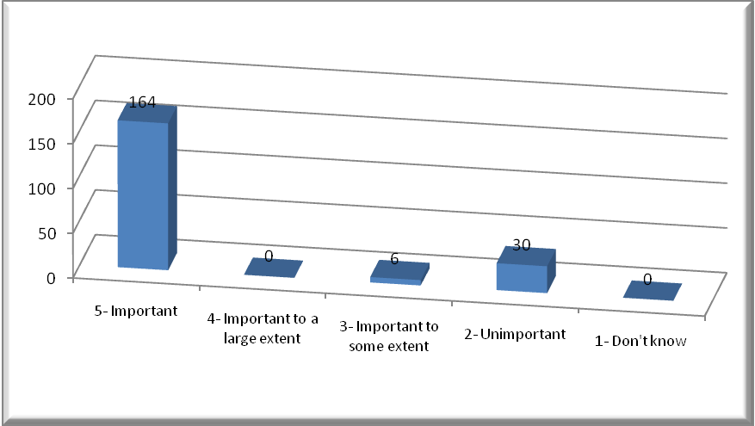
Figure 4.1: Staff Skills
Based on the above table, it is evident that a large number of staff members in DIB stress on the need of developing staff skills in the bank (82%) (Abdul-Majid, Saal & Battisti, 2010). Developing skills is vital since only 15% of the total persons interviewed disagreed with opinion, and 3% could not give their views towards the use of technology to shaping the skilled competency of staff in a bank (see Figure 4.1).

4.2 Bank interest in bringing customers

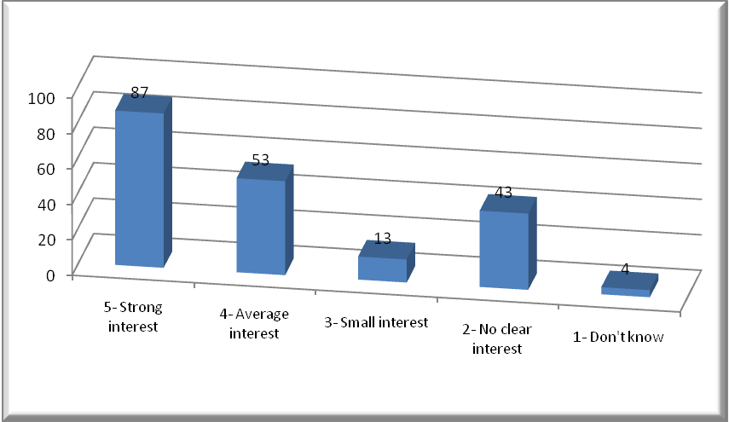
Figure 4.2: Bank interest in bringing customers
The above figure gives a clear view that 87 participants have a strong interest in bringing customers into the bank, 53 are on average status, 13 small, 43 not clear and four do not know(Hassan & Aliyu, 2018). The above results bring forth an illustration that the bank does not involve employees in the process of making decisions and planning process (see Figure 4.2).

4.3 bank interest in developing the skills of employees

Figure 4.3: bank takes an interest in developing the skills of employees
The above picture provides that 48.5% of participants have a strong interest in developing the skills of staff in the bank, 32% are on average status, 7.5 % small, 11.5 % not clear and 0.5 do not know(Hassan & Aliyu, 2018). The above results show that half of the employee does not understand the rationale behind core competency for the success of the bank (see Figure 4.3).

4.4 Customer service benefits to the bank

Figure 4.4: employeesthe benefits for the bank from customer service
The above figure confirms that 80% of 200 participants have a strong belief that the services offered to the customers are of much importance. 16.5% of the participants seem to partially agree with the above statement, 1.5 did not know, 1% disagreed and 1% strongly disagreed (Kadiwala & Prajapati, 2019). The results show that the bank has tried to enlighten its employees on the benefits accrued from developmental management of customer service.

4.5suggestions for an increase in sales

Figure 4.5: suggestions for an increase in sales
The above-presented figure confirms that the employees in DIB bank have a strong idea that sales volume need to be increased. Approximately three-quarters of the total population, which is 140 participants strongly, agreed that sales required to be boosted, 40 partially agreed, five did not know, 11 disagreed, and 4 had a strong feeling that there was no need for increasing sales (Kadiwala & Prajapati, 2019).

CHAPTER FIVE

DISCUSSION

5.1 Importance of developing skills
The results generated in section confirm that most of the employees in the bank have a clear view that the development of skills is vital in an organization. It is worth noting that NIB bank has been educating its members on skill development, which would aid in achieving their goals and meeting the challenges facing the new banks (Maghyereh, 2018).

5.2. Interest in bringing in customers
The question relating to bringing customers into the bank did not attract much attention to almost half of the bank's staff. Precisely, only 78 out of 200 participants showed keen interest in encouraging customers to seek financial services from the bank. As a result, the bank needs to put more emphasis on planning process while cooperating with various departments to bring customers in the bank, thereby increasing the number of service users (Qureshi, Pillai & Sing, 2018).

5.3. Banks interest in developing the employee's skills
The result in chapter four confirms that 48% of employees had a strong feeling that their skills needed to be developed. Therefore, there seems to be no positive relationship between skill development and training as well as high academic performance (Qureshi, Pillai & Sing, 2018). Based on the above illustration, it is evident that the bank has not been putting efforts to improve the performance of staff concerning the technological advancement.

5.4 The benefits of customer service for the bank
The NIB staffs have a clear view that the services offered to the customers are vital in developing the activities of a bank. The results provide that over 80% of the employees had a strong feeling that the services offered to the customer are significant in taking the organization to the next level (Bose, 2018). The bank can boost its service provision through sales promotion, engaging with customers at a personal level and offering other services which are not provided in other conventional banks.

5.5 Suggestion for sales increase
The question on employee suggestion was vital in proving the validity of the previous data that planning is pivotal in boosting staff skills as well as sales volume. Notably, 140 employees out of 200 suggested that they would strongly support the strategies for increasing sales volume. The NBI bank should get it clear that boosting sales volume is a complex undertaking since it entails effective management of finances, administrative activities, human resources and general organizational aspects (Hassan & Aliyu, 2018).

CHAPTER SIX

RECOMMENDATIONS AND CONCLUSIONS

6.0 Introduction
This chapter is utilized to give a wrap up of the entire research. It provides the critical results of the study, the problems faced by DIB bank staff while trying to achieve their goals. Besides, it will give the NBI’s recommendation for achieving its goals and the gap for further research.

6.1Important Issues
Need for Sales increase, bringing more customers, developing employee skills and the need for competency among the employees are crucial aspects discussed in the research.

6.2 Challenges and Recommendations
After reviewing the information provided by NBI employees, it is evident that the bank is falling short of effective communication with the subordinate staff (Bose, 2018). The team lacks acceptable skills in the field of banking because they cannot accommodate the demands of the industry. The bank should review its policies on accommodation and rehabilitation of employees to ensure that core competencies are upheld while minding economic and humanitarian dimensions.
NIB bank has been struggling with the issue of boosting its sale volume due to poor planning and making uninformed decisions. The staff does not have the necessary skills for marketing the products provided by the bank (Abdul-Majid, Saal & Battisti, 2010). The bank will need to put in place interventions for boosting its administrative functions, marketing, sales and operational strategies. These interventions will pave the way for winning more customers and creating a substantial competitive edge.
Notably, the bank has been facing challenges when it comes to raising the standards of services provided to be in line with the customer's demands. The underlying research enlightens that the staffs in DIB bank do not have the capability of coping up with the ever-advancing level of technology (Kadiwala & Prajapati, 2019). The bank’s management should put more emphasis on employing only the potential candidates in addition to shaping their skills based on technological advancements.
The research has confirmed that NIB bank has been facing challenges on attracting customers to the bank. The primary cause for this issue is poor marketing strategies which cannot induce a potential customer to have confidence in the services provided (Hassan & Aliyu, 2018). The bank can boost its service provision through sales promotion, engaging with customers at a personal level and offering other services not provided in other conventional banks.

6.3 Future Research
The research paper paves the way for other scholars who may wish to dig deep on the studies relating to the banking systems in the United Arab Emirates. Again, research on the contribution of technology towards building the skills of employee needs to be conducted (Hassan & Aliyu, 2018). Importantly, research on how banks can develop the skills of staff to attain customer-based services and escalated sales volume demands an attention

6.4 Conclusion
All in all, banks contribute hugely in community growth through funding customers activities, thereby providing a balance between demand and supply of services offered. Banks contribute significantly to developing the economy through the mobilization of savings and providing a cost-effective environment for money exchange. However, the banking system in UAE has been experiencing various challenges, including the need for Sales increase, convincing customer, developing employee skills and the development for competency among the employees. As a result, the research has provided a recommendation for the above challenges as well as the gap for further analysis.

References
Abdul-Majid, M., Saal, D. S., & Battisti, G. (2010). Efficiency in Islamic and conventional
banking: an international comparison. Journal of productivity analysis, 34(1), 25-43
.Bose, I. (2018). Employee empowerment and employee performance: An empirical study on
selected banks in UAE. Journal of Applied Management and Investments, 7(2), 71-78.
Hassan, M. K., & Aliyu, S. (2018). A contemporary survey of Islamic banking literature. Journal
of Financial Stability, 34, 12-43.
Jan, M. T. (2018). Will It Survive? Challenges Faced by Islamic Banking and Finance in
today’s world. Journal of Islamic Finance, 176(6217), 1-10.
Kumar, R. (2019). Research methodology: A step-by-step guide for beginners. Sage Publications
Limited.
Kadiwala, M. A. G., & Prajapati, R. I. (2019). Financial Performance of State bank of India and
Dubai Islamic Bank: A comparative Study.
Maghyereh, A. I. (2018). Bank Competition, Concentration and Risk-taking in the UAE Banking
Industry Economia Internazionale/International Economics, 71(2), 129-148.
Qureshi, T. M., Pillai, M. R., & Singh, A. (2018). Investing in Success: Role of HRM Strategies
on Performance Sustainability in the UAE Banking Industry. World, 9(1).

